Candidate Information Pack
School of Primary Care, Population Sciences and Medical Education
Faculty of Medicine

Part of the
Page 1 of 18

Candidate Information Pack

Post title: | Clinical Professor/Clinical Associate Professor
Schools: | Primary Care, Population Sciences and Medical Education
Faculty: | Faculty of Medicine (FoM)
Career Pathway: | Clinical | Level: | Consultant
Salary: | £93,666 | To | £126,281
Clinical category: | Balanced portfolio
Posts responsible to: | Head of School
Posts responsible for: | Research Staff and Postgraduate Research Students as appropriate

Particulars of appointment
The Faculty of Medicine wishes to appoint a Clinical Professor/Clinical Associate Professor in the School of Primary Care, Population Sciences and Medical Education (PPM).

SCHOOL INFORMATION
Primary Care, Population Sciences and Medical Education (PPM) is one of five Schools in the Faculty of Medicine (Head of School, Professor Nick Francis). PCRC is the largest group in PPM, which also contains a Public Health group, Medical Education group, and NIHR Research Design Service (RDS) South Central.
The School encompasses a wide range of academic disciplines for applied health research: clinical primary care and public health; epidemiology; medical statistics, qualitative methods, health economics, and health psychology. There is a single management and administrative structure with bi-monthly team meetings of all senior academic staff, responsible for policy, strategic planning, and research oversight with strategic Away Days. We have strong research collaborations with relevant clinical disciplines in the Faculty of Medicine and methodologists and clinicians in other Faculties, (notably in Psychology, Medical Sociology, Statistics, Health Sciences and Geography).
Primary Care Research Centre
The PCRC is part of the School of Primary Care, Population Sciences and Medical Education (PPM), within the Faculty of Medicine, and provides an energetic, productive and nurturing research environment. We aim to produce world-leading research, informed by patient and public involvement (PPI), working with health professionals and policy makers and developing research students, to strengthen primary care practice and improve patient outcomes. In the 2021 Research Excellence Framework (REF), Southampton PCRC achieved the highest rating in our unit of assessment for outputs with a Grade Point Average of 3.71 and 94% considered as 'internationally excellent' or 'world leading'. Southampton PCRC is a member of the NIHR School for Primary Care Research.
We are looking to appoint an enthusiastic GP clinical academic who will develop a programme of high-quality research in an area that complements our PCRC research themes (and further information below). We are seeking an experienced clinical academic GP with an existing or emerging national or international reputation in this discipline. The postholder will be expected to lead and co-ordinate substantial research projects of strategic importance, have experience of successfully obtaining funding for research and a track-record of publishing research findings in high quality peer reviewed journals. The successful candidate will also be expected to contribute to the delivery of teaching to both undergraduate medical students and postgraduate students and provide academic supervision to researchers wishing to undertake PhD/MDs.

Primary Care Research Centre
Research themes
Diagnosis and prognosis
Healthcare communication
Data Science
Improving use of medicines
Supporting self-management
Content areas
Infections and antibiotics Long-term conditions
Healthy ageing Integrative healthcare

PRIMARY CARE RESEARCH CENTRE
PCRC has 9 professors, 5 associate professors, 3 clinical lecturers, 3 clinical research fellows, 20 post-docs, 8 doctoral students, and 32 research staff.

Our research strategy is built on strengths in five overlapping themes and four cross-cutting clinical areas of focus.

Research Themes:
- Supporting self-management: Addressing increasing needs for self-management of infections, including new viruses, non-communicable long-term conditions, and disability, for an ageing population facing increasing multimorbidity, frailty, and polypharmacy. It builds on our close links with Psychology and international reputation for developing and evaluating digital interventions.

- Improving use of medicines: This includes studies describing medicine use and associated outcomes, qualitative studies of patient and prescriber perspectives, and trials evaluating effectiveness of medicines and optimal use (including deprescribing where appropriate).

- Healthcare communication: Improving patient outcomes by optimising healthcare interactions, including developing tools to enhance empathy and positive messages, evaluating agenda-setting within consultations, and detailed conversation analysis of video- and audio-recorded consultations to improve communication.

- Diagnosis and prognosis: This includes prospective observational studies, routine data studies, qualitative studies, diagnostic studies and randomised trials to improve the management of common conditions in primary care. Ongoing studies focus on diagnosis and prognosis of COVID-19, sore throat, urinary tract infection (UTI), asthma and chronic obstructive pulmonary disease (COPD), mental health problems, atrial fibrillation (AF), and cancer.

- Data Science: Uses large volumes of complex, heterogenous, multi-dimensional and often unstructured dataset from different sources with the aim of understanding patterns, trends, and associations of risk factors, preventive and curative interventions, and diseases to inform improve health and wellbeing at population level. We use sophisticated statistical methods alongside artificial intelligence algorithms to draw insights on real-world problems.

Cross cutting these themes are our main clinical areas of:
- Infections and antibiotic stewardship

- Long-term conditions (respiratory; mental health; skin; gastrointestinal; musculoskeletal; cancer; cardiovascular etc.)

- Healthy ageing

- Integrative health care

Research Students
Currently we have 7 PPM doctoral students registered in the Faculty, all jointly supervised by two or more academics. In addition, we have 8 students jointly supervised, but registered with other groups (mainly Health Psychology and Health Sciences), arising from our extensive collaborations. We support and attract research students through:
- Membership of the NIHR School for Primary Care Research, giving access to annually awarded non-clinical PhD studentships and Primary care focussed research training;
- Being one of 10 departments nationally to be awarded Wellcome-funded Clinical PhD fellowships for GP doctorates;
- Ensuring all investigators undergo EDI and supervisor training to maximise capacity;
- The Associate Dean for Research’s programme of workshops and individual support for applications for external fellowships including mock interviews.
Our doctoral students undertake individualised learning needs analyses within a month of enrolment and agree tailored training and an annual formal assessment with an adviser outside the supervisory team. PPM provides funding for training and conference attendance and holds a very successful annual PhD presentation conference.
Students receive training and support in PPI, and access to Faculty generic research methods training and pastoral support through programmes run by the Graduate School and Southampton Clinical Academic Training Scheme.

Primary Care Research Centre – Senior Staff
Head of PPM: Professor Nick Francis
Head Primary Care: Professor Hazel Everitt
Professor Helen Atherton
Professor Tony Kendrick
Professor Geraldine Leydon
Professor Paul Little
Professor Tracey Sach
Professor Miriam Santer
Associate Professor: Dr Hajira Dhamba-Miller
Associate Professor Adam Geraghty
Associate Professor Kinda Ibrahim
Associate Professor Nazrul Islam
Associate Professor Leanne Morrison
Associate Professor Ingrid Muller
Associate Professor Kay Wang
Clinical Lecturer: Dr Mark Lown
Clinical Lecturer: Dr Merlin Willcox
NIHR Clinical Lecturer: Dr Sara McKelvie

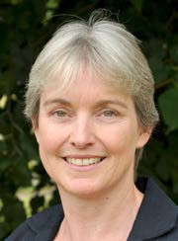
Top row L-R: Nick Francis, Hazel Everitt, Helen Atherton, Tony Kendrick, Geraldine Leydon, Paul Little.
Middle row L-R: Tracey Sach, Miriam Santer, Hajira Dambha-Miller, Adam Geraghty, Kinda Ibrahim, Nazrul Islam. Bottom row L-R: Leanne Morrison, Ingrid Muller, Kay Wang, Mark Lown, Merlin Willcox, Sara McKelvie.

Population Health Sciences
Our public health researchers are leading interdisciplinary projects to better understand the patterns and causes of poor health and to develop interventions that enhance the prevention, early detection and management of ill health and which ensure a more equitable distribution of health and wellbeing.
Our studies involve collaboration across a range of disciplines in the Faculty of Medicine and across the University which includes epidemiology, medical statistics, health economics, geography, demography, social sciences and primary care. We also have a number of regional collaborations (Wessex Public Health Reference Group, NIHR ARC Wessex, Southampton BRC), national collaborations across the UK, as well as internationally, including in India, China, sub-Saharan Africa, Europe and North America.
Our public health research underpins our substantial teaching commitments at both undergraduate and postgraduate levels. We believe that the next generation of clinicians and healthcare professionals should have a better understanding of the drivers to health inequalities and the scope for prevention, and of the underlying research evidence. Our teaching incorporates aspects of global health and planetary health.

Public Health Sciences – Senior Staff at Southampton
Head: Professor Julie Parkes
Deputy Head of School Research: Professor Simon Fraser
Professor Nisreen Alwan
Professor Simon Fraser
Professor Kalyanaraman Kumaran
Professor Nuala McGrath
Associate Professor Ryan Buchanan
Associate Professor Kate Glyn-Owen
Associate Professor Sara Morgan
Associate Professor Emma Plugge

Top row L-R: Julie Parkes, Nisreen Alwan, Simon Fraser, Nuala McGrath.
Bottom row L-R: Kate Glyn-Owen, Ryan Buchanan, Sara Morgan.

FACULTY OF MEDICINE
The Faculty of Medicine celebrated its 50th Anniversary in 2021. The creation of the Faculty of Medicine enabled the building of strong foundations of basic and clinical research. Working with colleagues across the University and in the local NHS we are a renowned centre for primary care and translational research, leading innovative learning, discovery, dissemination and implementation for better health. Key to the success of the Faculty of Medicine is the delivery of high-quality education for undergraduate and postgraduate students.

The PCRC and the wider Faculty of Medicine operate as part of a highly-functioning collaborative network locally, regionally, nationally and internationally.
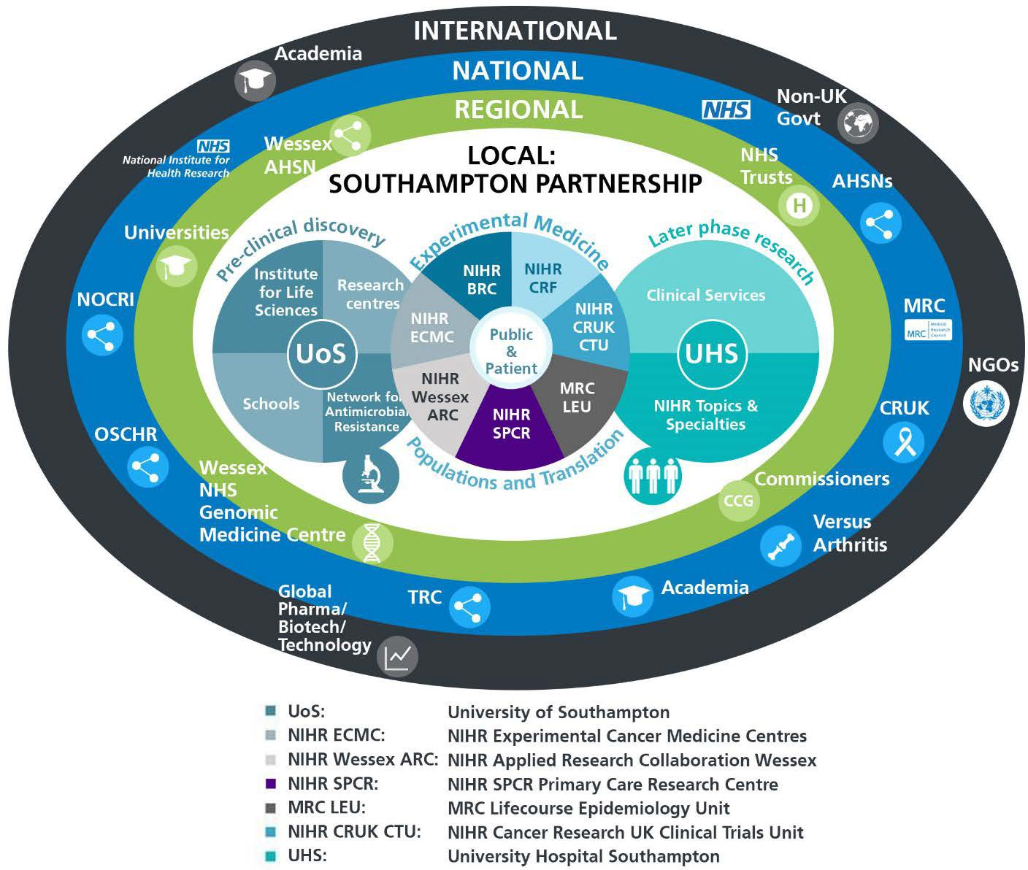

UNIVERSITY OF SOUTHAMPTON
The University of Southampton is a leading research-intensive University, a member of the Russell Group and one of the top 100 universities worldwide. We deliver an excellent educational experience, world-leading research and we are known for successfully commercialising that research through enterprise.

This is an exciting time to join the University of Southampton. We have an aspirational University Strategy www.southampton.ac.uk/strategy, setting out our ambitions over the next five years.
The strategy involves achieving a top 10 place in the UK for research, which we will achieve by investing in the highest quality staff and facilities. We are also transforming the education offer available to undergraduate and postgraduate students across the University, providing greater flexibility and modular courses, with a strong international focus.

Southampton Behaviours
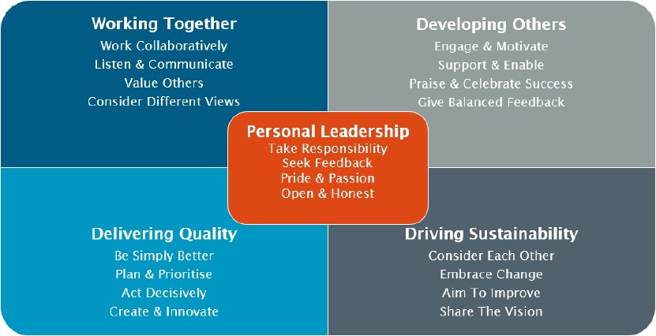

The Student Experience
We offer a range of undergraduate programmes: the BM4 programme, a graduate-entry four-year programme which accepts 48 students per year; and the BM5 and BMedSc programme which accepts 200 students per year including approximately 30 students from a BM6 programme aimed at widening access to a medical career. Students also join the first two years for teaching in Southampton on the BM(EU) Programme, an affiliation with a German Medical school in Kassel.
Biomedical/ Psychosocial Teaching in the first two years of the BM programmes is delivered in the South Block of Southampton General Hospital as well as on Highfield campus. Clinical teaching takes place at Southampton General Hospital and the adjoining Princess Anne Hospital, the Royal South Hants Hospital, and in NHS Trusts and General Practices throughout Hampshire, Dorset, West Sussex and Salisbury.
The BM5 programme has several distinctive features. These include the integrated nature of teaching where the scientific disciplines are taught together in a clinical context using a systems- based approach and the BMedSc programme, a four-month supervised research project undertaken in Year 3. There is also the opportunity, for selected students, to undertake an integrated, intercalated Masters in Medical Science (MMedSc). The BM4 programme also has several key features. These include clinical topics in the first two years where students meet on a regular basis in Graduate Groups and learning with BM5 students in the third and fourth years on all clinical attachments. All students take the same final examinations. All programmes have substantial clinical experience in the first two years, student selected components, dispersed final year attachments, work shadowing prior to commencing a Foundation post and inter-professional learning.
In addition to the undergraduate BM programmes the School of PPM provides four Masters Degree programmes in Public Health, Allergy, Genomics and Diabetes plus an MRres.

Enterprise
The Faculty of Medicine Enterprise Strategy is fully aligned to the University Enterprise Strategy to provide a step change to its enterprise and innovation culture, delivering global outreach, community engagement, innovative healthcare and policy. We work with all stakeholders from industry and pharma to health providers and the community.

Equality, Diversity and Inclusivity
We are committed to positively advancing equality of opportunity. We participate in a number of equality initiatives which celebrate good employment practice for the advancement of diversity, equality and inclusivity. These include the Stonewall Workplace Equality Index, the Race Equality Charter and Athena Swan, (for which we are currently silver award holders). We also have a number of staff equality committees who champion the advancement of equalities for diverse groups.

Job Description and Person Specification
Last updated: 26/03/2024

JOB DESCRIPTION

Post title: | Clinical Associate Professor
School/Department: | Primary Care, Population Sciences & Medical Education
Faculty: | Medicine
Career Pathway: | Clinical | Level: | Consultant
*ERE category: | Balanced portfolio
Posts responsible to: | Head of School
Posts responsible for: | Junior Staff and students as appropriate
Post base: | Office-based

Job purpose
To undertake research in line with the School/Department research strategy, to teach at undergraduate and postgraduate level, and to undertake leadership, management and engagement activities.

Key accountabilities/primary responsibilities |  | % Time
 | Plan and coordinate a broad research programme and activity in an area of recognised excellence for the University. Act as principal investigator on projects, responsible for defining original research objectives, developing and managing staff, and attracting funding through bids and reputation. Develop and oversee the application of innovative and creative research methodologies and techniques that add to the knowledge/understanding of the subject area. | 55 %
 | Develop and sustain a national and international reputation for research and the enhancement of learning and teaching practice by the regular dissemination and explanation of findings through leading peer-reviewed publications, major conferences, or exhibiting work at other appropriate events. Engage in external academic activities in accordance with the School/Department research strategy and which enhance the School/Department national/international research profile, e.g. membership of committees of academic bodies, external examining, journal editorships, etc. | 5 %
 | Manage administrative tasks associated with specified research funding, including risk assessment of programme activities, leading project meetings and preparation of annual reports. Management of procedures required to ensure accurate and timely formal reporting and financial control. | 5 %
 | Contribute to the development of teaching and learning activities of the School/Department. Deliver teaching of the highest quality across a range of modules and to all levels, through lectures, tutorials, practicals and seminars. | 20 %
 | Contribute to the development of research, teaching and learning strategies in the School/Department. | 5 %
 | Provide expert advice and subject leadership to other staff and students, including research supervision. | 5 %
 | Any other duties as allocated by the line manager following consultation with the post holder. | 5 %

Internal and external relationships
Member of the School/Department Board, Examination Board and of such School/Department committees relevant to their administrative duties.
The post holder will take a leading role in the setting of strategic objectives for the research theme of which they are a member.
Teaching and administrative duties will be allocated by the Head of School/Department, within the context of the teaching programmes agreed by the School/Department Learning and Teaching Committee.

Special Requirements
To attend national and international conferences for the purpose of disseminating research results.

PERSON SPECIFICATION

Criteria | Essential | Desirable | How to be assessed
Qualifications, knowledge and experience | A practicing primary care clinician. with a primary medical qualification and full registration with the GMC.  Inclusion on GMC Specialist Register.  PhD or equivalent professional qualifications and experience in an applied health research field  Well-established national and international reputation in Primary Care or Public Health Research  Extensive track record of teaching at undergraduate and postgraduate level. Extensive track record of developing and disseminating successful learning approaches.  Extensive track record of published research | Membership of Higher Education Academy  Inclusion on UKPHR  Involvement in national and international events  Teaching qualification (PCAP or equivalent) | CV  Application  References  Interview
Planning and organising | Proven ability to plan and shape the direction of an area of research and teaching activity, ensuring plans complement broader research and education strategy  Proven ability to develop innovative research proposals and attract research funding  Proven ability to plan, manage, organise and assess own teaching contributions.  Proven ability in the design of course units, curriculum development and new teaching approaches in the School/Department, taking primary responsibility for their quality  Able to contribute to the development of research and teaching policy within the School/Department | Able to build research/teaching teams | CV  Application  References  Interview
Problem solving and initiative | Able to develop significant new concepts and original ideas within own field in response to intractable issues of importance to the research area |  | CV  Application  References  Interview
Management and teamwork | Able to mentor, manage, motivate and coordinate teaching/research teams, delegating effectively. Able to resolve performance issues and formulate staff development plans, where appropriate, to ensure team aims are met  Proven ability to manage and deliver own course units and team-taught course units  Proven ability to coach, advise and support others (staff and students) on learning and teaching issues.  Able to foster and develop good relationships between own School/Department and the rest of the university. Able to work proactively with senior colleagues to develop cross-School/Department and institution cooperation and effectiveness  Able to contribute to the running of the School/Department by managing significant School/Department processes  Able to monitor and manage resources and budgets  Work effectively in a team, understanding the strengths and weaknesses of others to help teamwork development |  | CV  Application  References  Interview
Communicating and influencing | Communicate new and complex information effectively, both verbally and in writing, engaging the interest and enthusiasm of the target audience  Extensive track record of presenting research results at group meetings and conferences  Extensive track record of delivering lectures and seminars in courses relating to different aspects of (subject area)  Able to engage counselling skills and pastoral care, where appropriate  Able to persuade and influence at all levels in order to foster and maintain relationships, resolving tensions/difficulties as they arise  Able to provide expert guidance to colleagues in own team, other work areas and institutions to develop understanding and resolve complex problems  Able to negotiate for the School/Department on key issues  Able to develop and lead key communications strategies |  | CV  Application  References  Interview
Other skills and behaviours | Compliance with relevant Health & Safety issues  Positive attitude to colleagues and students |  | CV  Application  References  Interview
Special requirements | Able to attend national and international conferences to present research results |  | CV  Application  References  Interview

JOB HAZARD ANALYSIS

Is this an office-based post?
☐ Yes | If this post is an office-based job with routine office hazards (eg: use of VDU), no further information needs to be supplied. Do not complete the section below.
☒ No | If this post is not office-based or has some hazards other than routine office (eg: more than use of VDU) please complete the analysis below.  Hiring managers are asked to complete this section as accurately as possible to ensure the safety of the post-holder.

## - HR will send a full PEHQ to all applicants for this position. Please note, if full health clearance is required for a role, this will apply to all individuals, including existing members of staff.

ENVIRONMENTAL EXPOSURES | Occasionally  (<30% of time) | Frequently  (30-60% of time) | Constantly  (> 60% of time)
Outside work
Extremes of temperature (eg: fridge/ furnace)
## Potential for exposure to body fluids
## Noise (greater than 80 dba - 8 hrs twa)
## Exposure to hazardous substances (eg: solvents, liquids, dust, fumes, biohazards). Specify below:
Frequent hand washing
Ionising radiation
EQUIPMENT/TOOLS/MACHINES USED
## Food handling
## Driving university vehicles(eg: car/van/LGV/PCV)
## Use of latex gloves (prohibited unless specific clinical necessity)
## Vibrating tools (eg: strimmers, hammer drill, lawnmowers)
PHYSICAL ABILITIES
Load manual handling
Repetitive crouching/kneeling/stooping
Repetitive pulling/pushing
Repetitive lifting
Standing for prolonged periods
Repetitive climbing (ie: steps, stools, ladders, stairs)
Fine motor grips (eg: pipetting)
Gross motor grips
Repetitive reaching below shoulder height
Repetitive reaching at shoulder height
Repetitive reaching above shoulder height
PSYCHOSOCIAL ISSUES
Face to face contact with public
Lone working
## Shift work/night work/on call duties

Job Description and Person Specification
Last updated: 26/03/2024

JOB DESCRIPTION

Post title: | Clinical Professor
School/Department: | Primary Care, Population Sciences & Medical Education
Faculty: | Medicine
Career Pathway: | Clinical | Level: | Consultant
*ERE category: | Balanced portfolio
Posts responsible to: | Head of School
Posts responsible for: | Junior Staff and students as appropriate
Post base: | Office-based

Job purpose
To lead research in line with the School/Department research strategy, to teach at undergraduate and postgraduate level, and to undertake leadership, management and engagement activities.

Key accountabilities/primary responsibilities |  | % Time
 | To lead, plan and coordinate a broad research programme and activity in an area of recognised excellence for the University. Act as principal investigator on projects, responsible for defining original research objectives, developing and managing staff, and attracting funding through bids and reputation. Lead the application of innovative and creative research methodologies and techniques that add to the knowledge/understanding of the subject area. | 55 %
 | Build on an existing national and international reputation for research and the enhancement of learning and teaching practice by the regular dissemination and explanation of findings through leading peer-reviewed publications, major conferences, or exhibiting work at other appropriate events. Engage in external academic activities in accordance with the School/Department research strategy and which enhance the School/Department national/international research profile, e.g. membership of committees of academic bodies, external examining, journal editorships, etc. | 5 %
 | Manage administrative tasks associated with specified research funding, including risk assessment of programme activities, leading project meetings and preparation of annual reports. Management of procedures required to ensure accurate and timely formal reporting and financial control. | 5 %
 | Contribute to the development of teaching and learning activities of the School/Department. Deliver teaching of the highest quality across a range of modules and to all levels, through lectures, tutorials, practicals and seminars. | 20 %
 | Contribute to the development of research, teaching and learning strategies in the School/Department. | 5 %
 | Provide expert advice and subject leadership to other staff and students, including research supervision. | 5 %
 | Any other duties as allocated by the line manager following consultation with the post holder. | 5 %

Internal and external relationships
Member of the School/Department Board, Examination Board and of such School/Department committees relevant to their administrative duties.
The post holder will take a leading role in the setting of strategic objectives for the research theme of which they are a member.
Teaching and administrative duties will be allocated by the Head of School/Department, within the context of the teaching programmes agreed by the School/Department Learning and Teaching Committee.

Special Requirements
To attend national and international conferences for the purpose of disseminating research results.

PERSON SPECIFICATION

Criteria | Essential | Desirable | How to be assessed
Qualifications, knowledge and experience | A practicing primary care clinician with a primary medical qualification and full registration with the GMC  Inclusion on GMC Specialist Register.  PhD or equivalent professional qualifications and experience in an applied health research field  A significant national and international reputation in Primary Care, Public Health, or Population Health Research  A sustained record of excellence in teaching at undergraduate and postgraduate level. Extensive track record of developing and disseminating successful learning approaches  A sustained record of excellence in research activities | Membership of Higher Education Academy  Inclusion on UKPHR  Involvement in national and international events  Teaching qualification (PCAP or equivalent) | CV  Application  References  Interview
Planning and organising | Proven ability to champion and oversee key contributions to faculty and/or University research, education and enterprise strategies.  Proven ability to lead research activities, grants and/or contracts of national and international importance.  Proven ability to lead the development of education strategies in the faculty through ongoing leadership in the dissemination of knowledge and/or curriculum development. | Able to build research/teaching teams | CV  Application  References  Interview
Problem solving and initiative | Proven ability to implement successful change management initiatives and formulate strategic plans that reflect and support the priority needs of the faculty and University. |  | CV  Application  References  Interview
Management and teamwork | Proven ability to oversee people and resource management processes in order to deliver key education, research and enterprise activities.  Proven ability to make a sustained contribution to academic leadership at discipline, School/Department and faculty level.  Proven ability to demonstrate leadership abilities in Higher Education and to raise performance standards through own work areas.  Proven ability to recognise and deal with obstacles and difficulties so that the team can deliver. |  | CV  Application  References  Interview
Communicating and influencing | Proven ability to establish and build major relationships with stakeholders. Proven ability to act as the main figurehead for key activities, developing important national and international contacts.  Able to contribute to the development of the University’s profile in the UK and internationally.  Proven ability to use influence to develop positions or strategies. |  | CV  Application  References  Interview
Other skills and behaviours | Compliance with relevant Health & Safety issues  Positive attitude to colleagues and students |  | CV  Application  References  Interview
Special requirements | Able to attend national and international conferences to present research results |  | CV  Application  References  Interview

JOB HAZARD ANALYSIS

Is this an office-based post?
☒ Yes | If this post is an office-based job with routine office hazards (eg: use of VDU), no further information needs to be supplied. Do not complete the section below.
☒ No | If this post is not office-based or has some hazards other than routine office (eg: more than use of VDU) please complete the analysis below.  Hiring managers are asked to complete this section as accurately as possible to ensure the safety of the post-holder.

## - HR will send a full PEHQ to all applicants for this position. Please note, if full health clearance is required for a role, this will apply to all individuals, including existing members of staff.

ENVIRONMENTAL EXPOSURES | Occasionally  (<30% of time) | Frequently  (30-60% of time) | Constantly  (> 60% of time)
Outside work
Extremes of temperature (eg: fridge/ furnace)
## Potential for exposure to body fluids
## Noise (greater than 80 dba - 8 hrs twa)
## Exposure to hazardous substances (eg: solvents, liquids, dust, fumes, biohazards). Specify below:
Frequent hand washing
Ionising radiation
EQUIPMENT/TOOLS/MACHINES USED
## Food handling
## Driving university vehicles(eg: car/van/LGV/PCV)
## Use of latex gloves (prohibited unless specific clinical necessity)
## Vibrating tools (eg: strimmers, hammer drill, lawnmowers)
PHYSICAL ABILITIES
Load manual handling
Repetitive crouching/kneeling/stooping
Repetitive pulling/pushing
Repetitive lifting
Standing for prolonged periods
Repetitive climbing (ie: steps, stools, ladders, stairs)
Fine motor grips (eg: pipetting)
Gross motor grips
Repetitive reaching below shoulder height
Repetitive reaching at shoulder height
Repetitive reaching above shoulder height
PSYCHOSOCIAL ISSUES
Face to face contact with public
Lone working
## Shift work/night work/on call duties

